EXSM 3928: Code for Designers   
Final Response Assignment

Student: Md Shahadat Hossain  
Due: Dec 19, 2022

# Instructions

Make a **copy** of this document, **edit**, **export** as a **PDF** and **submit** on **eClass**.

Weekly assignments are **to be completed by Sunday evening (11:59pm)**.

The purpose of this assignment is to help students deepen their understanding of the content and practice skills in order to become faster or more proficient.

The assignment will be marked out of **ten points** based on the following criteria:

|  |  |  |
| --- | --- | --- |
| DESCRIPTION | VALUE | MARK |
| Document is **submitted** with proper **ccid**, **name**, and **date** | 2 |  |
| Assignment tasks are **complete** | 8 |  |

# Notes

Late submissions are received at a **reduced value**, see eClass for details.

Please **keep this cover page** attached.

# EXSM 3928 Final Response

* Complete this document
  1. Add ccid to title
  2. Add name to cover page
* Clearly answer the question “**to what extent should designers learn to code?**”
  1. Must clearly define what you believe to be a typical minimum coding ability or knowledge (can be zero)
  2. Must clearly define what you believe to be a typical maximum coding ability or knowledge (can be no limit)

|  |
| --- |
| **Answer: It depends. When you work with digital products, you may not always need to write lines of code, but it is an added advantage to know how to build the product that you design. If you have knowledge about coding then you can cooperate with developer easily in the time project handoff.** |

* Use at least three prompts from the class in your answer
  1. Must quote the class prompt **(use bold to easily identify the prompt)**
  2. Use your answer somehow to support your your argument to the main question (“to what extent should designers learn to code?”)
  3. See below for list of all seven prompts
* Use at least three code snippets to support your answer
  1. Watch the assignment video to learn more about formatting code snippets in Google Docs)
* Must include full sentences
  1. Target 1-2 pages for document length
  2. Proofread your own work
* Include all cover pages in final submission
* Weekly prompts
  1. …Should developers learn design principles? Why or why not?

|  |
| --- |
| **Answer: Yes, developers should learn design principles. It helps them to organize the styling of a project clearly. Placing items, giving functionality which is achievable will help them if they learn design principles.** |

* 1. What is your greatest challenge with learning code? What advice would you give to someone starting to learn design?

|  |
| --- |
| **Answer: My greatest challenge with learning code is learning CSS. Whenever you want something to do with CSS styling then you have to learn the core of it.** |

* 1. Do you need content before you design? Whose responsibility is creating content? Should a designer or developer be involved?

|  |
| --- |
| **Answer: Yes, I need content before I start designing with html & CSS. Designer should put content on the design. Otherwise, whenever developer will use real content, the design will breakdown.** |

* 1. What features of design software are similar to writing CSS? Are some tasks easier in code than in software? Which?

|  |
| --- |
| **Answer: VS Code, Atom, Brackets are design software similar writing CSS. Yes, VS Code helps to find out error in which line and have lots of extensions which helps to do easy coding in showing suggestions and in many other ways.** |

* 1. Why is JavaScript important? Can you make websites without JavaScript? Why is there so much JavaScript used today?

|  |
| --- |
| **Answer: JavaScript is important to give functionality to the website. No, in nowadays modern design must have to use JavaScript otherwise the animation and functionality won’t work. It is important today as it has various of frameworks like reacts, redux etc. which helps to make website dynamically.** |

* 1. Has learning HTML, CSS, and JavaScript affected your design process? How so? If not then describe your design process.

|  |
| --- |
| **Answer: Yes, it helps a lot in design process. It helps me to do a website step by step. Firstly, building structure then giving it style and the giving it functionality to make it working fully.** |

* 1. Why are breakpoints used? How many should a website have? What should a designer hand off to a developer?

|  |
| --- |
| **Answer: Breakpoints are used to make website responsive for every device. In general, there are 10 viewports to handle responsiveness but it can go further than this whenever it needed to be. A designer should hand off a desktop version and mobile version of the project with style guides.** |

# Question: To What Extent Should Designers Learn to Code?

|  |
| --- |
| **Answer: Erudition to code for designers is not essential. But if they ken marginally about code, they can apperceive a developer's perspective. It doesn't denote that they have to be an adept coder. But it would significantly advantage them if they kenned a little about how to code HTML and CSS, maybe remotely of JavaScript.** |

**Three Code Snippets:**

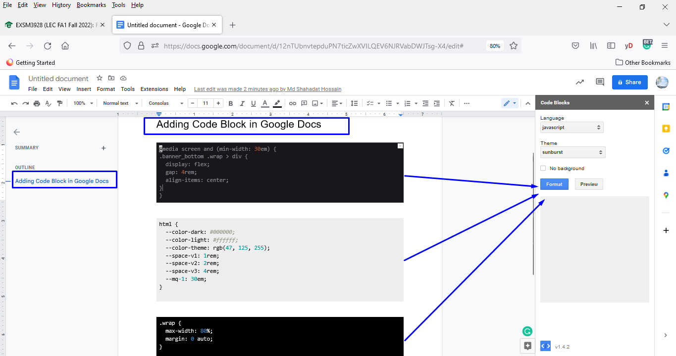

---------------------------------------------------------------------------------------------------------------------------------------------

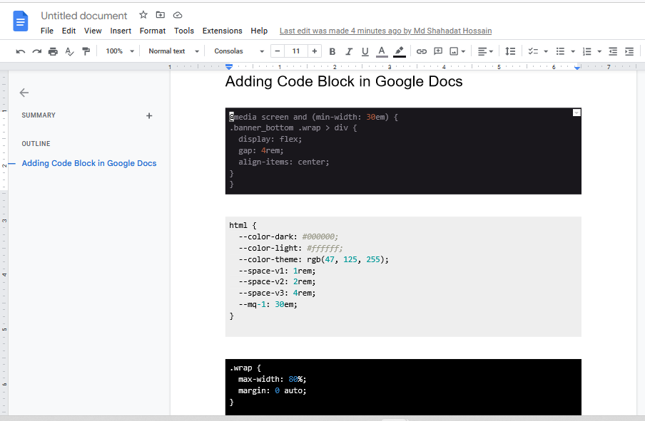

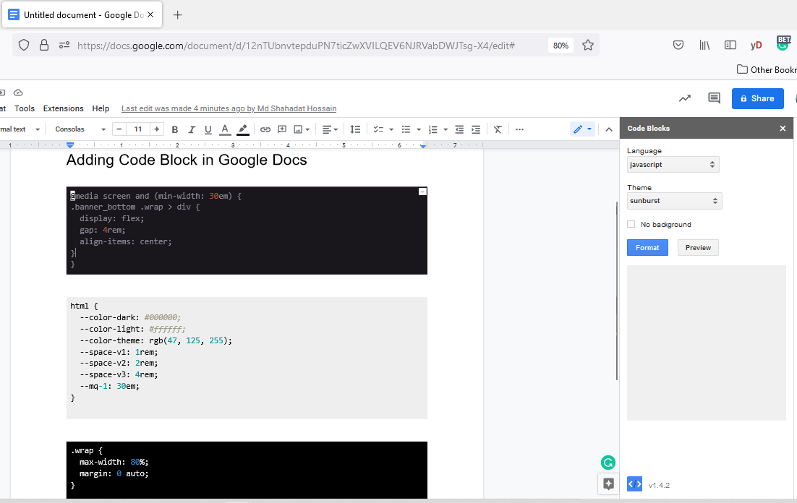

. . . example of formatted code with Google Docs extension “Code Blocks”

|  |
| --- |
| @media screen and (min-width: 30em) {  html {  --color-dark: #000000;  --color-light: #ffffff;  --color-theme: rgb(47, 255, 125);  --space-v1: 2rem;  --space-v2: 4rem;  --space-v3: 8rem; } } |

